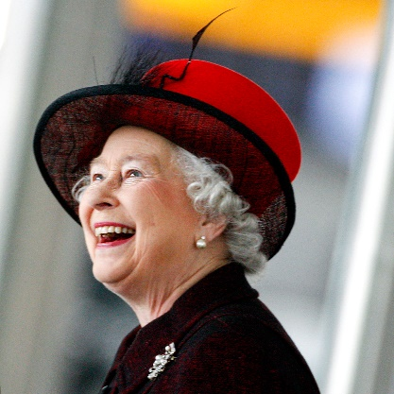
Your Majesty
thoughts shared by Margaret Toy

Along with many people, I imagine, I watched the recent broadcast of “The Unseen Queen” on BBC1. Towards the end, the Queen made a statement that she could not get to know all her subjects, help them all, make the laws or lead them in battle (as previous kings had at times of war) but she stated that she was able to give us her heart. Like many others, I believe she has served our country throughout her life and am very thankful for her.

The Queen’s statement made me think about our King. Our King is not restricted and He knows each of us better than we know ourselves. He has given us His laws, He leads us each day and He is able to help us at all times. He is never too busy with anything else to give us time. We have broken His laws but He is the One Who gave of Himself to pay the price and has saved us. What a King we have!

If anyone meets the Queen (I never have), he/she is expected to bow/curtsey and to address her correctly. Our God and King does not require any particular form of address and we can speak to Him at all times. Nevertheless, we must remember to Whom we are speaking. Our Father God is not there to our bidding – we are His subjects. He loves us with an everlasting love but that does not mean that we should expect Him to give us whatever we want – we are to love Him, worship Him and serve Him.

How wonderful that we love, serve and worship a God, Who loves us so much and we can do nothing to earn that love. At the same time, David recognised just how majestic God is:

O LORD, our Lord, how majestic is your name in all the earth!
You have set your glory above the heavens.
From the lips of children and infants you have ordained praise
because of your enemies, to silence the foe and the avenger.
When I consider your heavens, the work of your fingers,
the moon and the stars, which you have set in place,
what is man that you are mindful of him, the son of man that you care for him?
You made him a little lower than the heavenly beings
and crowned him with glory and honour.
You made him ruler over the works of your hands; you put everything under his feet:
all the flocks and herds, and the bests of the field,
the birds of the air, and the fish of the sea, all that swim the paths of the seas.
O LORD, our Lord, how majestic is your name in all the earth!
(Psalm 8 – NIV)

May we continue to give our God the glory – King of Kings and Lord of Lords.

