**Sue Hoyles**

Prayer & Resources

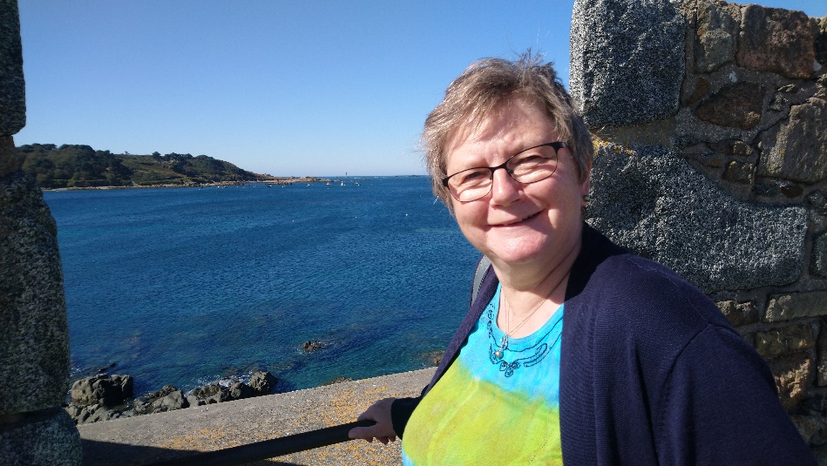I grew up in a Christian home and cannot remember a time when I was not a Christian, however there have been various significant times throughout my life when I have grown in my understanding of what it means to be a Christian.

I trained to be a nurse, knowing that I wanted to work with children. I spent many years working in Paediatric Intensive Care and other wards at Bristol Children’s Hospital before training as a Specialist Community Public Health Nurse (School Nursing) 15 years ago.

In 1985 Keith and I were married and our sons were born in 1990 and 1992. Our older son was 1 year old when I first joined a KYB group for young mums. I continued to be part of a KYB group and part of the Bristol KYB team until 2005 when I began studying for my School Nursing degree.

Life has been something of a rollercoaster ride but God has kept us through it all. We experienced a traumatic house move in 1997, our older son spent years struggling with CFS/ME (1999 – 2007) and my brother was diagnosed with a brain tumour (2006).

Since 2015 both my parents-in-law have passed away, our older son went abroad as a missionary, we have celebrated 4 family weddings as both of our sons and both of our nieces got married, I was diagnosed with breast cancer, my mum required open heart surgery and my brother passed away. This year we have welcomed our first grandson into our lives and a second grandson is due in November. Our Heavenly Father has been a constant through it all. I could write many pages on all that I have learnt during these times of joy and sorrow. We have learnt much about trusting God in the tough times and hanging on when everything seems dark. We have witnessed God’s perfect timing in so many ways and known His peace and His love.

I returned to full-time work in December 2017 following my cancer treatment. A year later I made the decision to retire early from work, I prefer to say I am “refocused” rather than “retired”! What would God want me to do with my time?! I made the decision to take time to consider this and not to rush into committing myself to “good” things that may not be God’s plan for me. I was certain that KYB would be a part of it, if only because I was keen to re-establish a KYB group where we live (Portishead). I had no idea that God would call me back to the Bristol KYB team. I felt somewhat overwhelmed when I was asked to join the NLT. I hold on to the knowledge that when God calls us to a task He enables us to do it.