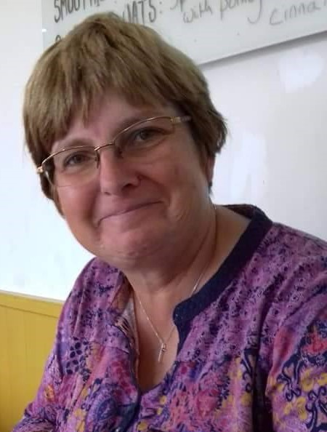
Sue Edgeler
SW KYB Studies Distributor

As I write this testimony and reflect on my walk with the Lord Jesus it’s amazing to see his hand upon my life.
As a child I was encouraged to go to Sunday School at the church my mum attended. It was during this time that I trusted Jesus for salvation whilst attending a Christian holiday. The loss of my mum when I was ten has had a lifelong impact and I am so grateful to the Lord for the godly women he has brought into my life. I started attending KYB events in 1980 and was immediately impressed by its focus on God’s Word and how I could live as a Christian.
Over the intervening years God has led me to lead a KYB bible study group which is such a thrill as I see God at work in the lives of women.
I have been part of the South West Regional Team since 1998 and on the National Team since 2004. This has been such a tremendous privilege to work with such godly women who have shared with me so much of themselves and their godly wisdom.

